CONTACT MANAGER

CONTACT MANAGER SYSTEM

Submitted by
Team Leader
Deepika S - (deepikashankar0301@gmail.com)
Team Members
Deepak S - (deepak0607007@gmail.com)
Chandru V -(c78721456@gamil.com)
Bharathi Sakthivel S -(sudhagarbharathi861@gmail.com)
Team ID
SWTID-2026-5924
Department of Computer Science with Data science
Institution Name: ST.THOMAS COLLEGE OF ARTS AND SCINCE
Academic Year: 2025 – 2026

TABLE OF CONTENTS
- Introduction
- Objectives of the Project
- Scope of the Project
- System Modules
- System Requirements
- Database Design
- System Architecture
- ER Diagram
- System Working
- Advantages and Limitations
- Future Enhancements
- Conclusion

INTRODUCTION
A Contact Manager System is a software application designed to store, organize, and manage contact information digitally. It acts as a digital address book where users can store details such as names, phone numbers, email addresses, and addresses.
The system allows users to easily add, search, update, and delete contact information whenever required. Contact management systems are widely used in personal and business applications to maintain organized contact records.

OBJECTIVES OF THE PROJECT
The main objectives of this project are:
- To create a digital system for storing contact information
- To allow users to add new contacts easily
- To provide a fast search function for finding contacts
- To allow updating of existing contact details
- To enable deletion of unnecessary contacts
- To maintain organized contact records using a database

SCOPE OF THE PROJECT
The Contact Manager System can be used for maintaining personal as well as professional contact information. It replaces manual record keeping with a digital system that is faster and more efficient.
This system can be used by individuals, small businesses, or organizations that need to manage contact information in an organized way.
SYSTEM MODULE

Delete Contact
Update Contact
Search Contact
View Contact
Add Contact

SYSTEM MODULES
Add Contact
This module allows users to add new contact information such as name, phone number, email, and address.

View Contacts
This module displays all stored contacts in a list format.
Search Contact
Users can search for contacts using different fields such as name or phone number.
Update Contact
This module allows users to modify or update existing contact details.
Delete Contact
This module allows users to remove contact records from the system.

SYSTEM REQUIREMENTS
Software Requirements
- Operating System (Windows / Linux / Mac)
- Database (MySQL / SQLite)
- Programming Language (Python / PHP / Java)
- Development Tools (VS Code, Notepad++, etc.)

DATABASE DESIGN

Table: Contacts
S | Data Type | Description
Contact_ID | Integer | Unique identifier
Name | Varchar | Contact name
Phone | Varchar | Phone number
Email | Varchar | Email address
Address | Text | Contact address
Notes | Text | Additional information

PRE-REQUISTES
SOFTWARE USED FOR THIS PROJECT
- Node.js
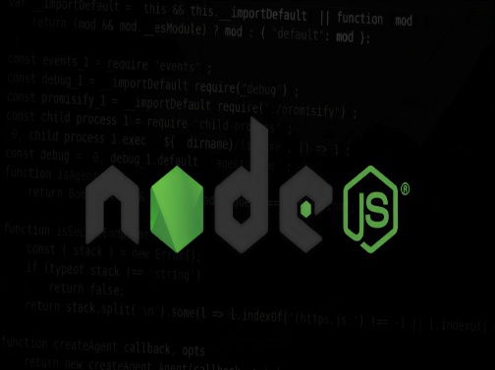
- Mangodb compass

This Photo by Unknown Author is licensed under CC BY-NC-ND
- Mangodb atlas
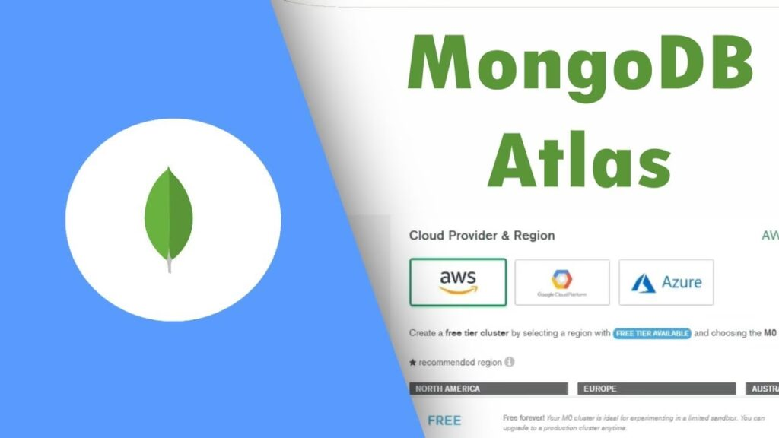
- Commend prompt

- VS Code


- Thunder clint

- NPM
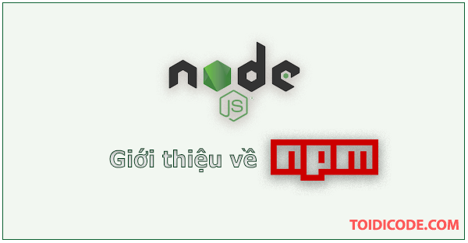
SYSTEM ARCHITECTURE
User → User Interface → Application Logic → Database
The user interacts with the system through an interface. The application processes the request and communicates with the database to store or retrieve contact information.

SYSTEM WORKING
- The user enters contact details through the interface.
- The system validates the entered information.
- The data is stored in the database.
- Users can view, search, update, or delete contact records when required.

ADVANTAGES AND LIMITATIONS
Advantages
- Easy management of contacts
- Fast search capability
- Organized data storage
- Reduces manual work
Limitations
- Basic version contains limited features
- Requires a computer system
- Security features may be limited in simple versions

FUTURE ENHANCEMENTS
The system can be improved by adding advanced features such as:
- Contact grouping (friends, family, business)
- Cloud storage support
- Mobile application version
- Contact image storage
- Backup and restore functionality

CONCLUSION
The Contact Manager System provides a simple and effective solution for managing contact information digitally. The system demonstrates how databases and software applications can be used to organize and manage data efficiently.
This project helps in understanding the basic concepts of database management and software system development.

Project video link
https://drive.google.com/file/d/11HCSGMm8w793xQx4xwlSh-QNe8Tpyqao/view?usp=drivesdk

Code link
https://drive.google.com/drive/folders/1w7HBIIl4u-uTfc63bdcR-RwfKofNHfD6

